# Activity 01 Part 2 – Two-Bit Comparator/Multiplier Using ROM

Richard Groves

09/05/2023

Class: ECE4/530 - Digital Hardware Design

# 1. Introduction

## 1.1 Objective

## The objective of this activity was to design, simulate, and implement a digital circuit capable of performing two distinct operations: comparison and multiplication of two 2-bit unsigned numbers. The design was to utilize ROM modules for storing predefined results of these operations and a multiplexor to facilitate the selection between comparison and multiplication functionalities.

# 2. Design

## 1.1 Design Approach

A modular design technique was used for this design.

### 1.1.1 Two-Bit Comparator/Multiplier

The two-bit comparator/multiplier was broken down into ROMs with a multiplexor to select between the two functions.

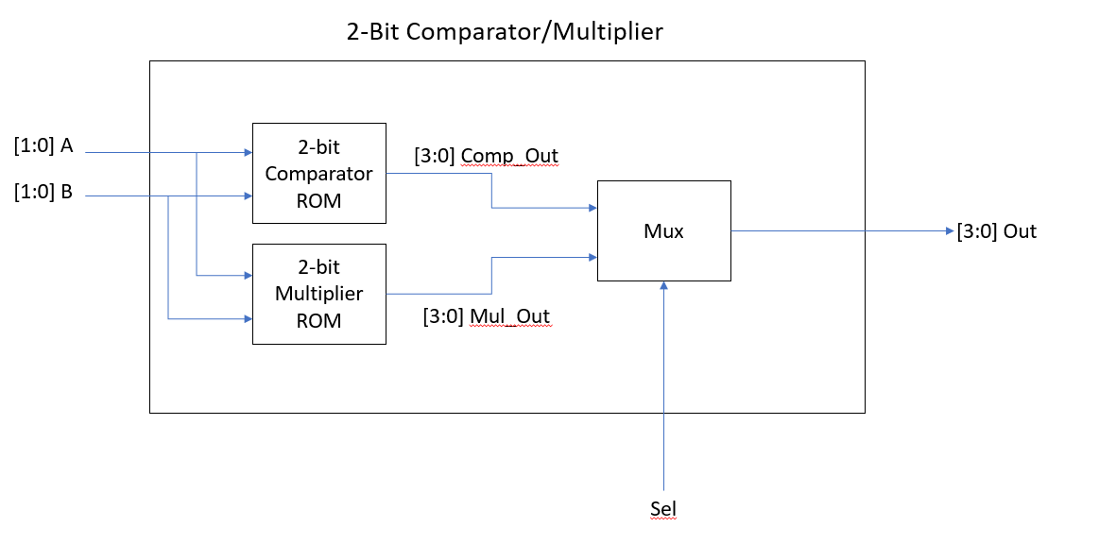

## 1.2 Design Details

### 1.2.1 Module List

The individual module files are included with this report.

|  |  |  |
| --- | --- | --- |
| Module Name | Module File Name | Module Description |
| Mul_2Bit | Mul_2Bit.v | This multiplier ROM stores predefined results of 2-bit unsigned number multiplications. |
| Comp_2Bit | Comp_2Bit.v | This comparator ROM stores predefined results of a 2-bit unsigned number comparator. |
| Comp_Mul_2Bit | Comp_Mul_2Bit.v | This module integrates comparison and multiplication functionalities, utilizing ROMs and a multiplexer to process and output respective results. |

### 1.2.2 Schematics

#### 1.2.2.1 Two-Bit Comparator/Multiplier Schematics

In the schematic of this module, there are two distinct two sub-modules representing the multiplier and comparator ROMs, each storing predefined results for their respective operations. The Mul_2bit module is responsible for carrying out multiplication operations, with the results being determined by the 4-bit address input, which is a concatenation of two 2-bit inputs 'a' and 'b'. Similarly, the Comp_2bit module performs comparison operations, outputting signals indicating whether the inputs are equal, or whether input ‘a’ is greater or less than ‘b’. The multiplexer directs the output from either the multiplier or the comparator to the 'out' output port, based on the state of the 'sel' signal. 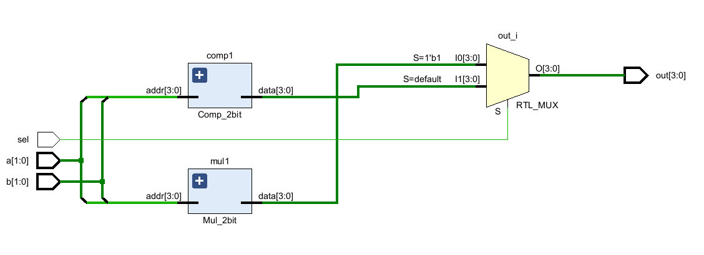

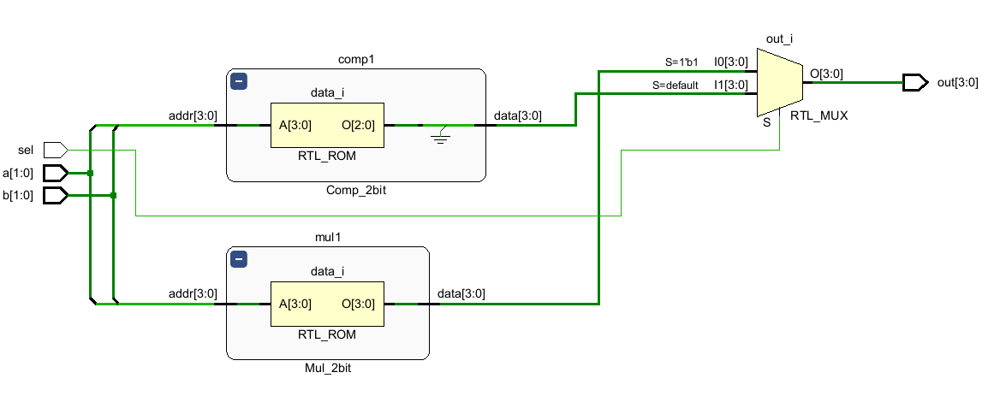

## 1.3 Simulation

### 1.3.1 Testbench Module List

The individual module files are included with this report.

|  |  |  |
| --- | --- | --- |
| Module Name | Module File Name | Module Description |
| tb_Comp_Mul_2bit | tb_Comp_Mul_2bit.v | This testbench module employs a loop structure to iterate through all possible input combinations for the Comp_Mul_2bit module. |

### 1.3.2 Waveforms

#### 1.3.2.1 tb_Comp_Mul_2bit Waveform

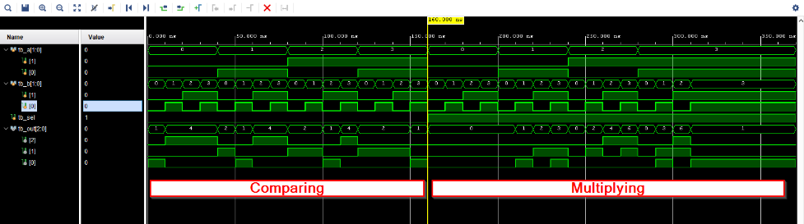

## 1.4 Synthesis

### 1.4.1 Slices/LUTs

|  |  |
| --- | --- |
| Slices | LUTs |
| SLICE_X43Y53 | Out_OBUF[1]_inst_i_1 |
|  | Out_OBUF[2]_inst_i_1 |

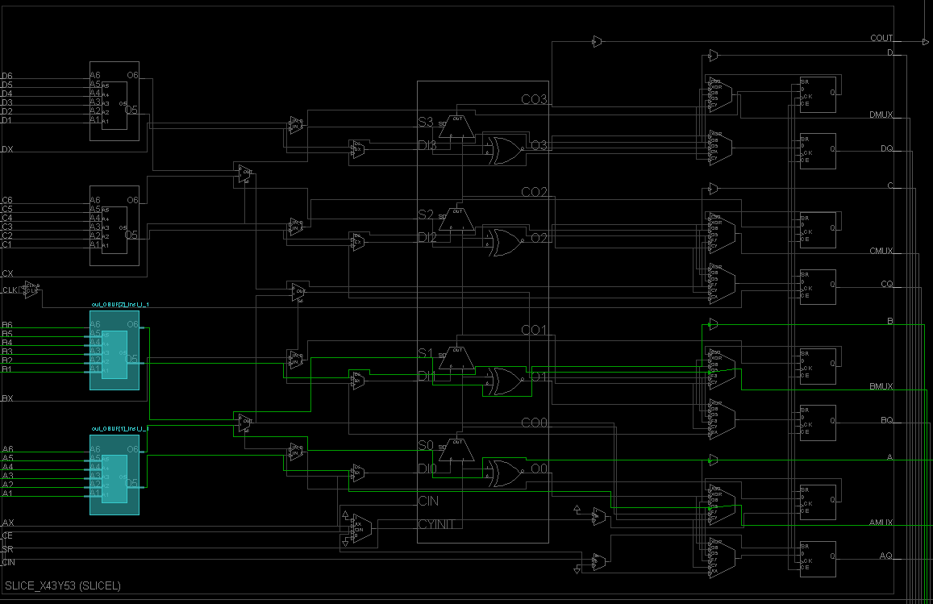

## 1.5 Implementation and Testing

### 1.4.1 Implementation Files

These implementation files are included with this report.

|  |  |
| --- | --- |
| File Name | File Description |
| Comp_Mul_2bit.bit | This is the bitstream file for the two-bit comparator/multiplier project. |

### 1.4.2 Testing

#### 1.4.2.1 3 Compared to 2

The image below shows a test comparing 3 to 2 (a compared to b) on the ZYBO-Z7 board.

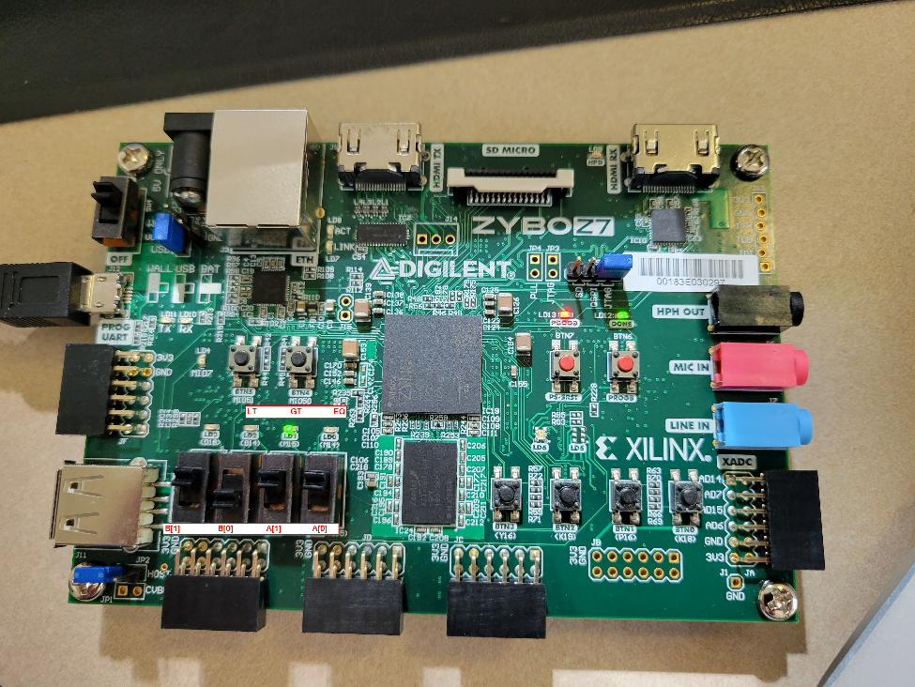

#### 1.4.2.2 1 Compared to 2

The image below shows a test of comparing 1 to 2 (a compared to b) on the ZYBO-Z7 board.

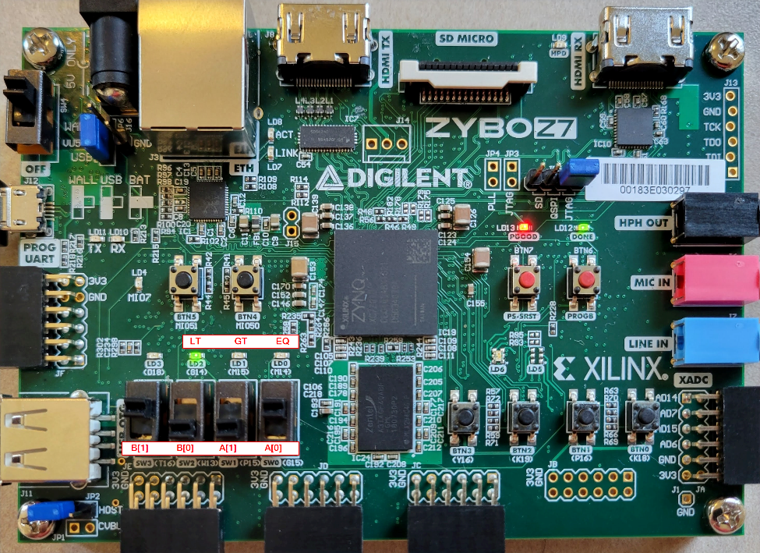

#### 1.4.2.3 3 Compared to 3

The image below shows a test of comparing 3 to 3 (a compared to b) on the ZYBO-Z7 board.

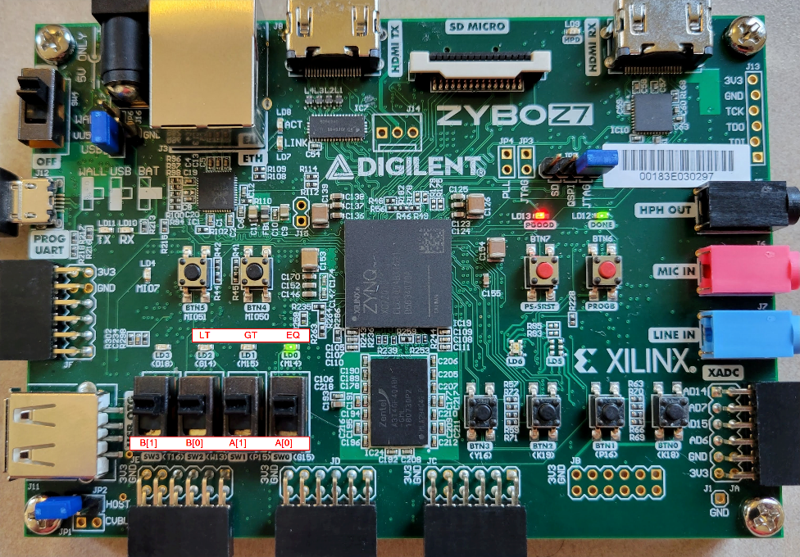

#### 1.4.2.4 1 Times 2

The image below shows a test of multiplying 1 times 2 (a x b) on the ZYBO-Z7 board.

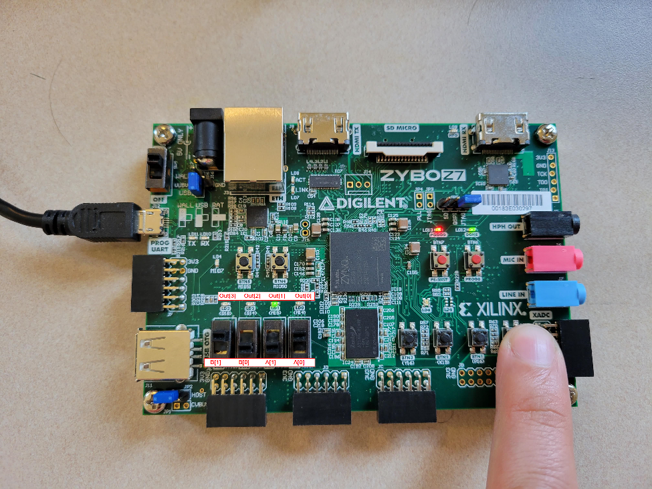

#### 1.4.2.4 3 Times 2

The image below shows a test of multiplying 3 times 2 (a x b) on the ZYBO-Z7 board.

